# Question 1



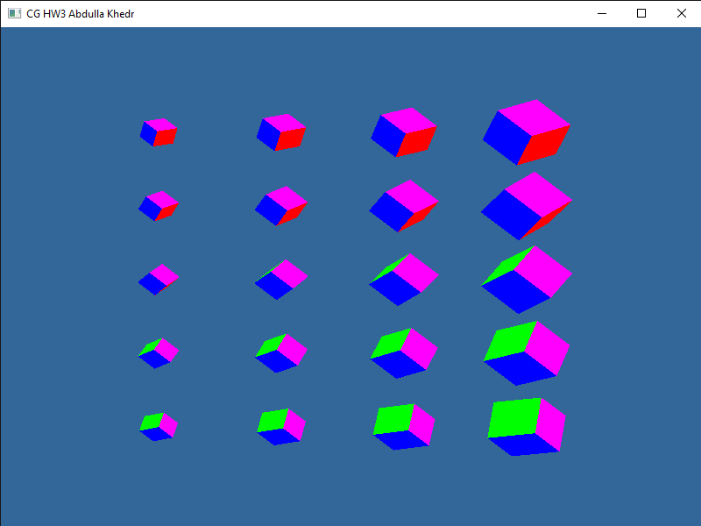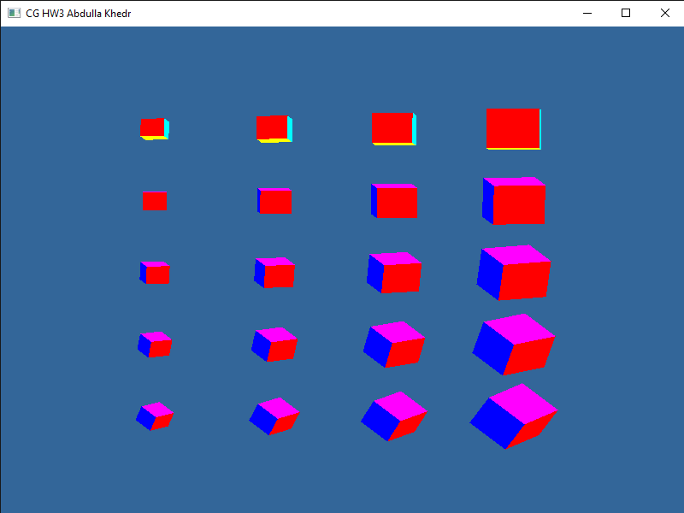

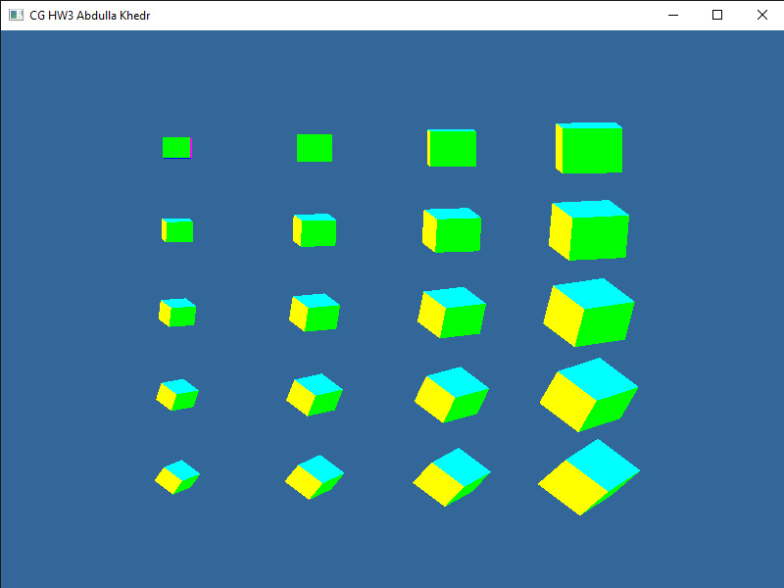

# Question 2

Firstly Scale by 0.5:

$$S=\left[\begin{matrix}s_{x} & 0 & 0 \\ 0 & s_{y} & 0 \\ 0 & 0 & 1\end{matrix}\right]=\left[\begin{matrix}0.5 & 0 & 0 \\ 0 & 0.5 & 0 \\ 0 & 0 & 1\end{matrix}\right]$$

Then translate by -1.5:

$$T=\left[\begin{matrix}1 & 0 & d_{x} \\ 0 & 1 & d_{y} \\ 0 & 0 & 1\end{matrix}\right]=\left[\begin{matrix}1 & 0 & -1.5 \\ 0 & 1 & -1.5 \\ 0 & 0 & 1\end{matrix}\right]$$

**Final Matrix translation matrix:**

$$TS=\left[\begin{matrix}1 & 0 & -1.5 \\ 0 & 1 & -1.5 \\ 0 & 0 & 1\end{matrix}\right]*\left[\begin{matrix}0.5 & 0 & 0 \\ 0 & 0.5 & 0 \\ 0 & 0 & 1\end{matrix}\right]=\left[\begin{matrix}0.5 & 0 & -1.5 \\ 0 & 0.5 & -1.5 \\ 0 & 0 & 1\end{matrix}\right]$$

# Question 3

Rotation matrix is

$$M_{r1}=\left[\begin{matrix}\frac{1}{\sqrt{5}} & 0 & \frac{2}{\sqrt{5}} & 0 \\ 0 & 1 & 0 & 0 \\ -\frac{2}{\sqrt{5}} & 0 & \frac{1}{\sqrt{5}} & 0 \\ 0 & 0 & 0 & 1\end{matrix}\right]$$

Now COP is at $(0,0,\sqrt{5})$

Translation matrix is

$$M_{t1}=\left[\begin{matrix}1 & 0 & 0 & 0 \\ 0 & 1 & 0 & 0 \\ 0 & 0 & 1 & -\sqrt{5} \\ 0 & 0 & 0 & 1\end{matrix}\right]$$

Now COP is at origin, and $z=-\sqrt{5}$

Apply the perspective projection

$$M_{pers}=\left[\begin{matrix}1 & 0 & 0 & 0 \\ 0 & 1 & 0 & 0 \\ 0 & 0 & 1 & 0 \\ 0 & 0 & -\frac{1}{\sqrt{5}} & 0\end{matrix}\right]$$ Translate back to $(0,0,\sqrt{5})$ $$M_{t2}=\left[\begin{matrix}1 & 0 & 0 & 0 \\ 0 & 1 & 0 & 0 \\ 0 & 0 & 1 & \sqrt{5} \\ 0 & 0 & 0 & 1\end{matrix}\right]$$

Rotate about the y-axis to move the COP from $(0, 0, \sqrt{5})$ back to its original location $(0, 2, 1)$

$$M_{r1}=\left[\begin{matrix}\frac{1}{\sqrt{5}} & 0 & -\frac{2}{\sqrt{5}} & 0 \\ 0 & 1 & 0 & 0 \\ \frac{2}{\sqrt{5}} & 0 & \frac{1}{\sqrt{5}} & 0 \\ 0 & 0 & 0 & 1\end{matrix}\right]$$

$$Finally M should be=M_{r2}M_{t2}M_{per}M_{t1}M_{r1}$$